Fast**National University of Computer & Emerging Sciences, Karachi  
Spring-2023 CS-Department  
Assignment no 2**

**Due date 9th April**

**Marks:100**

Q1. The TREE-CSP-SOLVER see figure below, makes arcs consistent starting at the leaves and working backwards towards the root. Why does it do that? What would happen if it went in the opposite direction?

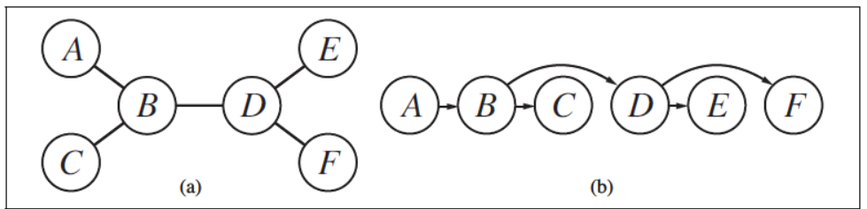

Q2. Solve the cryptarithmetic problem (CRACK +HACK = ERROR) by hand, using the strategy of backtracking with forward checking and the MRV and least-constraining-value heuristics.

Q3. Consider the following logic puzzle: In five houses, each with a different color, live five persons of different nationalities, each of whom prefers a different brand of candy, a different drink, and a different pet. Given the following facts, the questions to answer are “Where does the zebra live, and in which house do they drink water?”

The Englishman lives in the red house.

The Spaniard owns the dog.

The Norwegian lives in the first house on the left.

The green house is immediately to the right of the ivory house.

The man who eats Hershey bars lives in the house next to the man with the fox.

Kit Kats are eaten in the yellow house.

The Norwegian lives next to the blue house.

The Smarties eater owns snails.

The Snickers eater drinks orange juice.

The Ukrainian drinks tea.

The Japanese eats Milky Ways.

Kit Kats are eaten in a house next to the house where the horse is kept.

Coffee is drunk in the green house.

Milk is drunk in the middle house.

Discuss different representations of this problem as a CSP. Why would one prefer one representation over another?

Q3. Consider the game tree shown below. The top node is a max node. The labels on the arcs are the moves. The numbers in the bottom layer are the values of the different outcomes of the game to the max player. (10 Points)

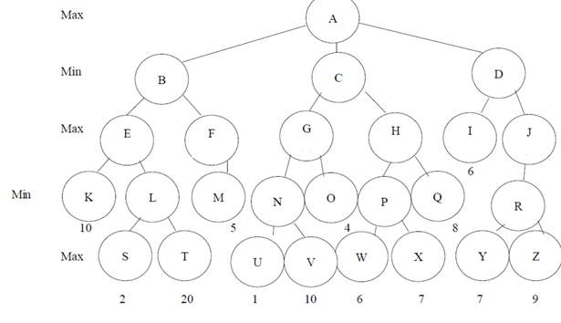

1. What is the value of the game to the max player?
2. What first move should the max player make?
3. Assuming the max player makes that move, what is the best next move for the min player, assuming that this is the entire game tree?
4. Using alpha-beta pruning, consider the nodes from right to left, which nodes are cut off? Circle the nodes that are not examined.

Q4. Refer the research articles gametheory1 and gametheory2 write the followings analysis:

1. What are the major findings of the papers?
2. How does the cognitive radio network use game theory to perform communication?
3. How does overlay spectrum sharing differ from the underlay resource sharing ?
4. Explain the utility function used by the system during the study of CRN in game theoretical farmwork.

Q5. Refer the research articles alphabeta1 and alphabeta2 write the followings analysis:

1. What are the major findings of the papers?
2. Explain the difference between Parallel (OpenMP) vs sequential Alpha Beta pruning.
3. Explain the difference between Parallel (CUDA) vs sequential Alpha Beta pruning.